

Comparing Mixed and Plug Flow Reactors

H83SP1: Process Simulation 1

Coursework Question 12

**Mohammed Hassan Miah**

**4254974**

**Introduction and Objectives:**

Comparing mixed (Continuous stirred tank reactor) and plug flow reactors (PFR) using HYSYS to calculate multiple variables for easy comparison between the 2 reactors.

* Determine which reactor is more efficient for production of ethyl acetate (CSTR or PFR?)
* Finding conditions for maximum production of ethyl acetate product.
* Optimizing process conditions for economic benefits.

**Assumptions:**

Negligible pressure drops across the reactors, steady state operation, Liquid level set to 50% by default. Plug flow no-radial variations in velocity, concentration, temperature, or reaction rate. Perfect mixing in CSTR.

**Non-obvious use and data:**

Fluid Package: Wilson, Component list: acetic acid, ethanol, water and ethyl acetate, Reaction set: Kinetics reaction, Stoichiometric coefficient -1 for reactants and 1 for products, Reverse order set to 0, CSTR is a cylindrical, horizontal vessel, no. of tubes in PFR is 1. Heat duty (adiabatic/isothermal). Number of tubes is 1. Void fraction (for PFR) is 1.

Reaction equation:

Acetic acid + Ethanol → Ethyl acetate + H2O

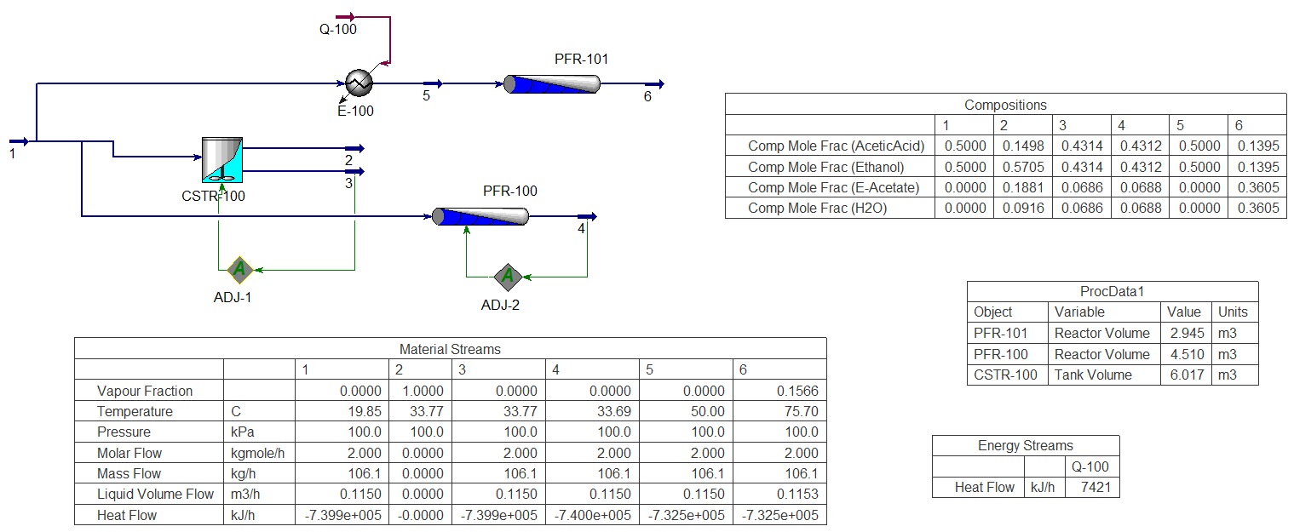Reaction rate 2nd order kinetics:

${-r}_{ethanol} = 4619.43 e (-\frac{60500}{8.314 T}) C_{acetic acid}C_{ethanol} [ kmol m^{3}s ]$

Figure 1

**Results**

* The CSTR volume required to produce desired output (0.13kmole/h of e-acetate) = 6.017 $m^{3}$.
* The PFR-100 volume required to produce desired output = 4.510 $m^{3}$.
* Plug flow reactor uses less volume (4.510 $m^{3}$) to achieve the product flow compared to CSTR (6.017 $m^{3}$).
* 7421.37kJ/h heat duty required for the feed stream 1 to reach 50℃ in stream 5.

1. PFR product mole fraction increase rapidly from 0.0165 to 0.1600 over PFR length 0m to 4m.
2. PFR product mole fraction increase slowly from 0.1600 to 0.361 over PFR length 4m to 15m.
3. PFR temperature increase rapidly from 53.3℃ to 82.3℃ over PFR length 0m to 4m.
4. PFR temperature decrease slowly from 82.3℃ to 75.7℃ over PFR length 4m to 15m.
5. Vapour fraction increase from 0 to 0.157 from PFR length 4m to 15m.
6. Reaction rate increases from ${6×10}^{-5}$ to ${1.7×10}^{-4}$ Kmol/ $m^{3}$ s over PFR length 0m to 4m.
7. Reaction rate decrease from ${1.7×10}^{-4}$ to ${2.5×10}^{-5}$ Kmol/ $m^{3}$ s over PFR length 4m to 15m.

**Supplementary Questions**

Using case studies tool in HYSYS, by investigation, modifying different variables the following increase the conversion towards ethyl acetate using the same PFR dimensions.

* From graph 5 preheat temperature to 89.66℃ for feed stream 5 produces max product flow.
* From graph 6 increasing feed stream 1 pressure up to 878.69KPa produces max product flow.
* From graph 7 total molar flow of 5kgmole/h gives highest product flow.
* 4 tubes in PFR gives highest product flow.

**Discussion**

The PFR volume is smaller than CSTR from figure 1 because the CSTR volume necessary to achieve a conversion at a given flow rate using the levenspiel plot is equal to the area of the rectangle with height equal to 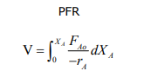  {\displaystyle F_{Ao} \over -r_{A}}and width equal to X. {\displaystyle X}The PFR volume necessary to achieve a conversion at a given flow rate is equal to the area under the curve of  {\displaystyle F_{Ao} \over -r_{A}}  plotted against {\displaystyle X}X using integration (Skogestad, 2008, p.265). So PFR is always a smaller reactor than a CSTR for a given conversion when kinetics is positive order.

The temperature drops after reaching 82.3℃ at PFR length 4m in graph 2 is due to some of the reaction enters vapour phase as the data indicates from graph 3 vapour starts forming and increases from PFR length 4m. This is likely due to the boiling points of ethanol and ethyl acetate are at 78℃ and hence vapour starts forming. Vapour fraction starts to increase at 4m reactor length shown; less ethanol in liquid phase reaction rate decrease at 4m shown in graph 4 therefore less reactants and hence PFR temperature decrease as this is an exothermic reaction.

Preheating the feed to 89.66℃ does give the highest flow rate, however there is very little product molar flow increase difference from preheating stream 5 to 50℃; therefore would not justify the economic cost of increasing the heat duty from 7421.37kJ/h to 17764.91 KJ/h for a small return. Preheating the feed also reduces the PFR volume as this aid the interaction between the reactants in PFR hence the decrease in volume to 2.945 $m^{3}$ shown in figure 1. Preheating feed for CSTR has no effect on reactor volume which means PFR is more economical due to lower capital costs.

**Conclusion**

PFR is more efficient than CSTR as it uses less volume to produce the same product molar flow, this coincides with the levenspiel plot. Preheating feed further reduces the volume of PFR but not CSTR making the PFR the better option due to lower capital costs.

Max product production: Use PFR, feed temperature 89.66℃, feed pressure 878.69KPa, feed flow 5kgmole/h, 4 tubes in PFR.

Optimal economic process conditions: Use PFR, feed temperature 55℃, feed pressure 340KPa, feed flow 4.5kgmole/h, 4 tubes in PFR.

**References**

1. **^** Skogestad, Sigurd (2008). Chemical and Energy Process Engineering. CRC Press. p. 265. ISBN 9781420087567.